Algunas distribuciones de probabilidad

Cesar Alejandro Cruz Salas

2023-08-11

##Problema 1

miu = 10   
sigma = 2  
x = seq(miu - 4*sigma, miu + 4*sigma, 0.01)  
y = dnorm(x,miu, sigma)  
plot(x,y, type = "l", col = "red", main = "Normal(10,2)")

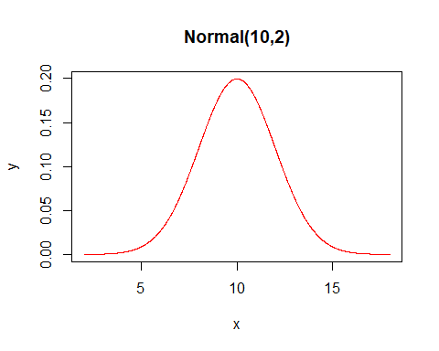 ##Problema 2

gl = 12 # Grados de libertad  
sigma = sqrt(gl/(gl-2))  
x = seq( -4*sigma, 4*sigma, 0.01)  
y = dt(x,gl)  
plot(x,y, type = "l", col = "blue", main = "T Student con gl = 12")

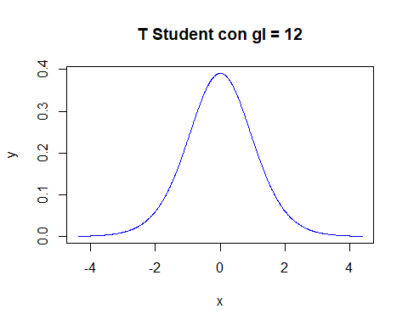

##Problema 3

gl = 8  
sigma = sqrt(2*gl)  
x = seq( 0, miu + 8*sigma, 0.01)  
y = dchisq(x,gl)  
plot(x,y, type = "l", col = "green", main = "Chi2 con gl = 8")

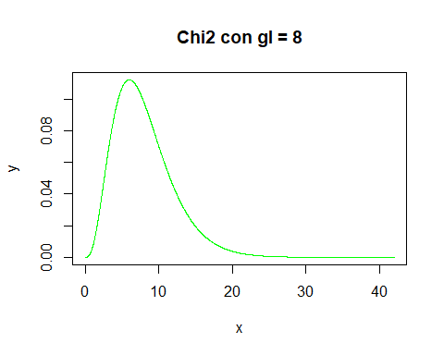 ##Problema 4

v1 = 9  
v2 = 13  
sigma = sqrt(2)*v2*sqrt(v2+v1-2)/(sqrt(v2-4)*(v2-2)*sqrt(v1))  
x = seq( 0, miu + 8*sigma, 0.01)  
y = df(x,v1, v2)  
plot(x,y, type = "l", col = "red", main = "F con v1 = 9, v2 = 13")

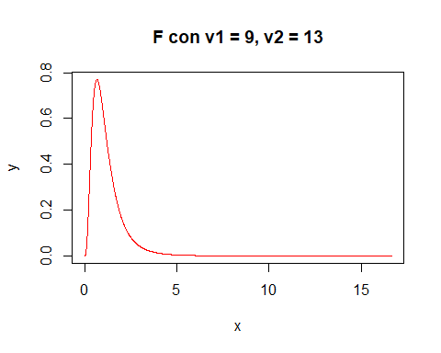 ##Problema 5

a=1-pnorm(0.7)  
a

## [1] 0.2419637

b=pnorm(0.7)  
b

## [1] 0.7580363

c=pnorm(0.7000000000001)-pnorm(0.6999999999999)  
c

## [1] 6.250556e-14

##Problema 6

qnorm(0.45)

## [1] -0.1256613

##Porblema 7

miu=100  
sigma=7  
  
a=pnorm(87,miu,sigma)  
a

## [1] 0.03164542

b=1-pnorm(87,miu,sigma)  
b

## [1] 0.9683546

c=pnorm(110,miu,sigma)-pnorm(87,miu,sigma)  
c

## [1] 0.8917909

##Porblema 8

gl=10  
a=pt(0.5,gl)  
a

## [1] 0.6860532

b=1-pt(1.5,gl)  
b

## [1] 0.08225366

c=qt(0.05,gl)  
c

## [1] -1.812461

##Problema 9

gl=6  
  
a=pchisq(3, gl)  
a

## [1] 0.1911532

b=1-pchisq(2, gl)  
b

## [1] 0.9196986

c=qchisq(0.95, gl)   
c

## [1] 12.59159

##Problema 10

v1=8  
v2=10  
  
a=pf(2, v1, v2)  
a

## [1] 0.8492264

b=1-pf(3, v1, v2)  
b

## [1] 0.05351256

c=qf(0.25, v1,v2)   
c

## [1] 0.6131229

##Problema 10

miu=65  
sigma=20  
R=100*pnorm(60,miu,sigma)  
  
print(paste('el resultado es', round(R,2),'%'))

## [1] "el resultado es 40.13 %"